Project Name | Decode
Project Environment | TABLE 1 Development Environment
  Hardware Environment | CPU | Intel Core i7-7700HQ,2.8 GHZ
  Hardware Environment | Memory | 16G
  Operating System | Windows | 10，Professional
  Development IDE | Visual Studio | Community 2022
Description of the process and outcome | • Read the Problem and Analyze Requirements  1.1 Project Requirements  - (1) Decrypt the ciphertext contained in the provided source code.  - (2) Determine key1, key2, key3, and key4 so that the program outputs the correct plaintext.  1.2 Analyze Clues in the Problem  - (1) The encrypted information is primarily stored in the data array.  - (2) First, try to solve for key1 and key2. If correct, a message starting with "From" will appear.  - (3) Then solve for key3 and key4 to obtain the final result.  • Solve for key1 and key2  2.1 Analyze the Main Function  - Select the code related to key1 and key2 for detailed analysis.  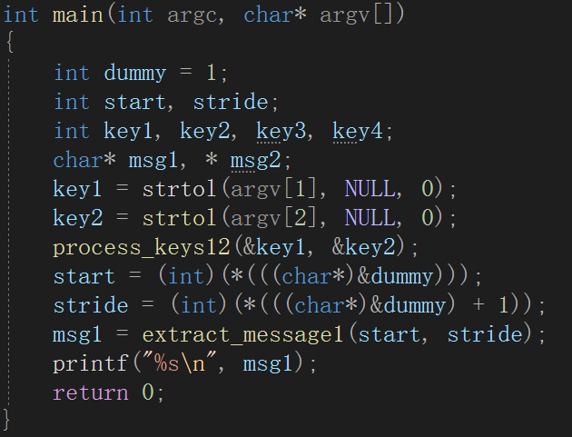  Figure 1: Analysis of key1 and key2 related code  To derive key1 and key2, one needs to refer to the final output in the console. The console output msg1 is the return value of extract_message1(start, stride). Further analysis of char * extract_message1(int start, int stride) is necessary.  2.2 Analyze the Function char * extract_message1(int start, int stride)  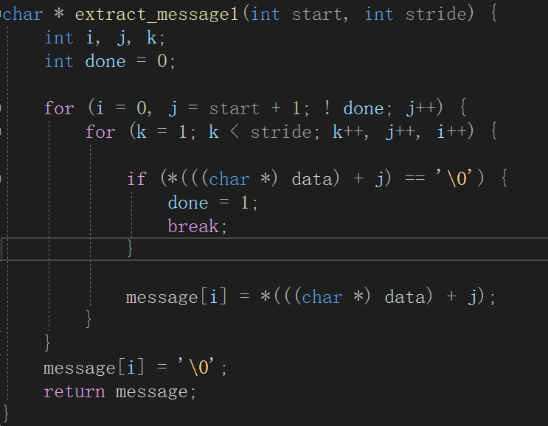  Figure 2: Analysis of the function extract_message1  This function converts each int value in an array into 4 characters, reading part of the resulting char array into message until a '\0' character is encountered.  The meanings of the two parameters are:  start: Read from position start + 1 in the converted char array.  stride: If stride > 1, read stride - 1 characters, skipping one character in between, continuing this until stride = 1, at which point no further reading occurs.  Therefore, the result of extract_message1 is determined by start and stride, and their values are controlled by Dummy  .  Figure 3: Relationship between start, stride, and dummy  Analyzing the expressions indicates that start corresponds to the lowest address byte of dummy, while stride corresponds to the second lowest address byte.  When dummy is 1, start = 1 and stride = 0, making it impossible to read data, and stride must be greater than 1. Therefore, we need to modify the value of dummy, and the only related function is process_keys12(&key1, &key2), which changes the value of dummy.  2.3 Analyze the Function process_keys12 to Calculate key1  This function adds the address of key1 (from the main function) to the value of key1 to obtain an address, then places the value of key2 (from the main function) into the memory pointed to by this address. Thus, the value of (int *)(key1 + *key1) equals the address value of the dummy variable. The value of key2 is also the value of dummy. Summarizing:  key1 = &dummy - &key1  key2 = dummy  Next, we debug the program to observe &key1 and &dummy:  Figure 4: Values of &key1 and &dummy  Since computer memory is measured in bytes, after converting to decimal, the value of &dummy - &key1 is 36. Because int is 4 bytes, key1 = 36 / 4 = 9.  Next, solve for key2; since key2 = dummy, and both start and stride values are related to dummy, we need to find the values of start and stride.  Note: During debugging, it was noted that the default capacity of message (100) was insufficient, so it was changed to 200.  2.4 Calculate the Values of start and stride to Determine key2  To determine start and stride, the data array needs to be converted into a character array, and reasonable start and stride values should be derived based on the problem prompt. The designed traversal function is as follows:  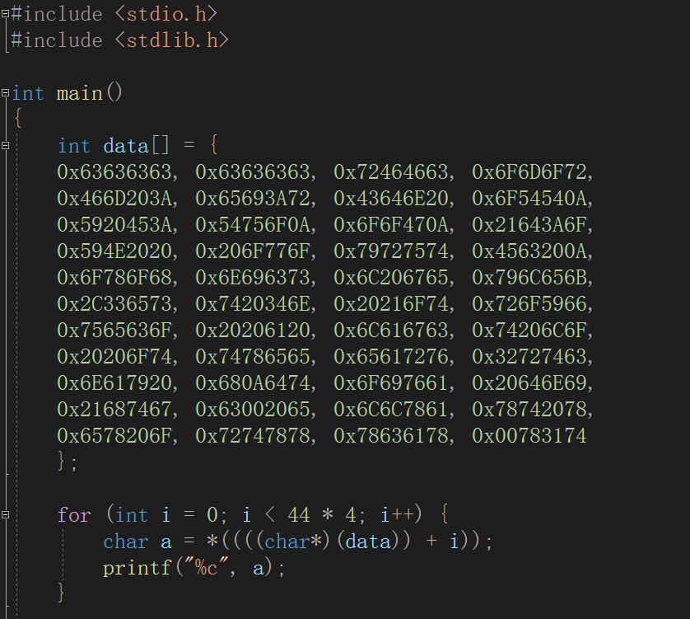  Figure 5: Traversing the data array  The results of the traversal are as follows:  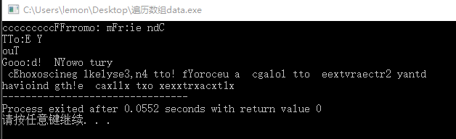  Figure 6: Traversal Results  To obtain reasonable information, it is clear that the message starts with "From" followed by "Friend". Thus, when start = 9 and stride = 3, it meets the criteria. To verify whether the results are correct, we slightly modified the source code and tested it, yielding the result:  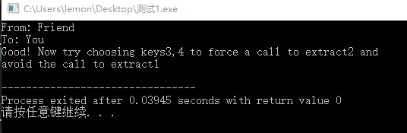  Figure 7: Verification of start and stride Results  Therefore, the value of dummy should be 0x****0309, so there are multiple valid values for key2, spaced by 0x10000 = 65536. Values such as 777, 66313, 131849, etc., satisfy this condition, and we take the smallest value, which is 777. Thus, key2 = 777.  3. Solve for key3 and key4  3.1 Analyze Related Code  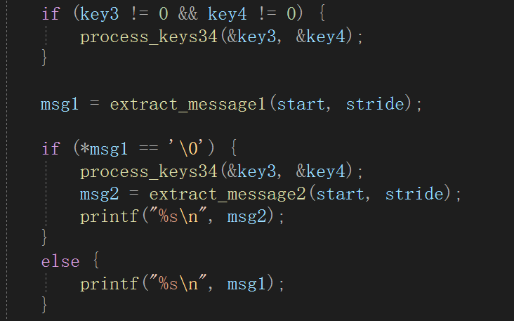  Figure 8: Code Related to key3 and key4  To obtain the correct result,，  msg2 = extract_message2(start, stride);  printf("%s\n", msg2);  must be run. Next, analyze the extract_message2 function：  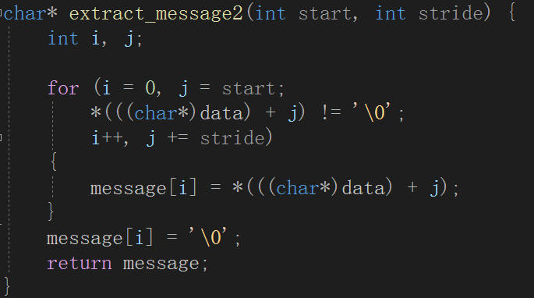  Figure 9 extract_message2 function  start：Starts from the element at index start in the char array.  stride: Reads one element every stride - 1 elements.  Continuing with the analysis of the process_keys34 function：  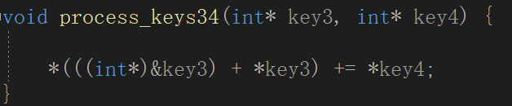  Figure 10 process_keys34 function  This function takes the address of key3 (in the main function), converts it to an int pointer, then adds the value pointed to by key3 to obtain an address, and offsets it by key4. The process_keys34 function can only modify the value at one address. Observing the data array, the only character that results in a '\0' is at the last address 0x00783174.  If this is the case, the string obtained from extract_message2 will have no value. To satisfy the condition, stride must be set to <= 1, which clearly does not yield the desired result.  Therefore, from the above analysis, we arrive at two conclusions:  (1) The values of start and stride are constant.  (2) If the program executes sequentially, there will inevitably be a contradiction.  It is evident that the process_keys34 function causes the program to jump, certainly skipping the if statement within process_keys34(&key3, &key4);, otherwise the program would enter an infinite loop. The principle behind the jump is based on the function call stack, which modifies the return address of the function:  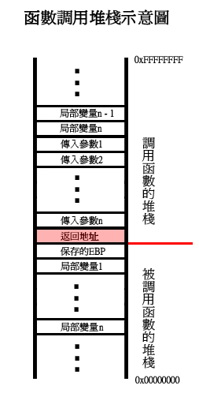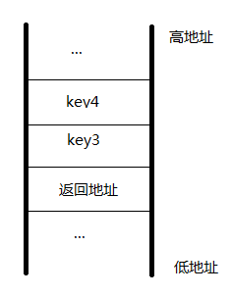  Figure 11 Analysis of the stack  Since the stack grows from high to low addresses, we get key3 = -1.  3.2 Analyze and Solve for key4  Key4 essentially determines where the program is to jump. If it jumps to the line before the conditional statement involving process_keys34(&key3, &key4), the program will enter an infinite loop. Thus, the function must jump to the line immediately following the return statement of process_keys34(&key3, &key4);. The value of key4 is the difference between the return addresses of the first and second calls to process_keys34(&key3, &key4);. This requires opening the disassembly window in Visual Studio to find the corresponding address values  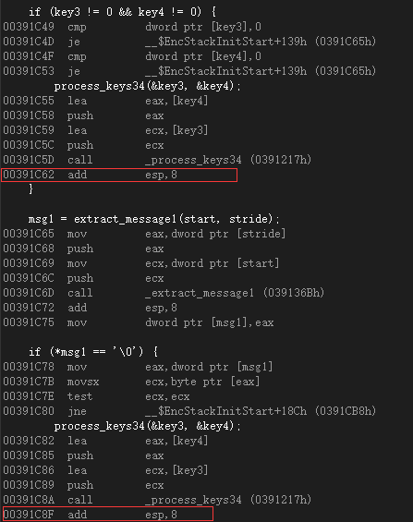  Figure 12: Disassembly to Find Addresses for key4  Thus, we find key4=00391C8F-00391C62=0x2d=45  Therefore, the final results are key1=9，key2=777，key3=-1，key4=45  4 Input Key Values to Verify the Final Resul    Figure 13 Verification of Final Results

